**CRITERIA - 4 Infrastructure and Learning Resources (100)**

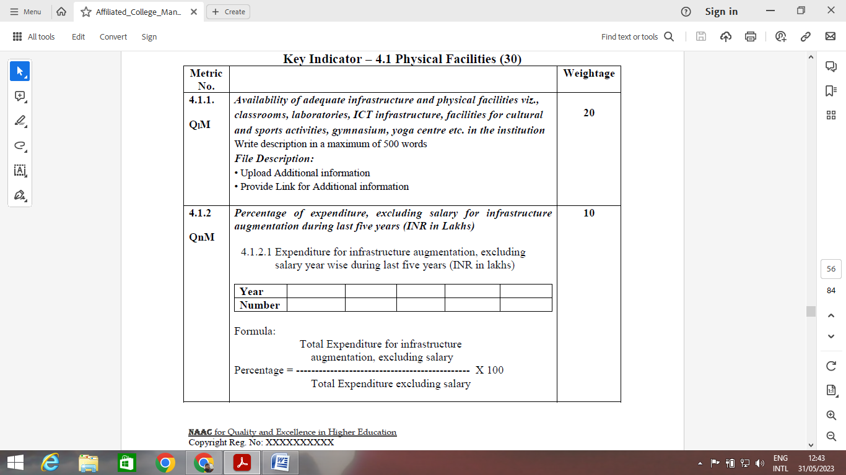

* Classrooms availability as per AICTE norms.

|  |  |  |  |  |
| --- | --- | --- | --- | --- |
| S. No | Room No. | Type | Area | Facilities |
|  |  |  |  |  |

* All the Classrooms with wifi, LCD, white screen along with GPS photographs should be uploaded.
* On letter head all the facilities to be printed along with classroom size, room nos. duly signed by Principal.



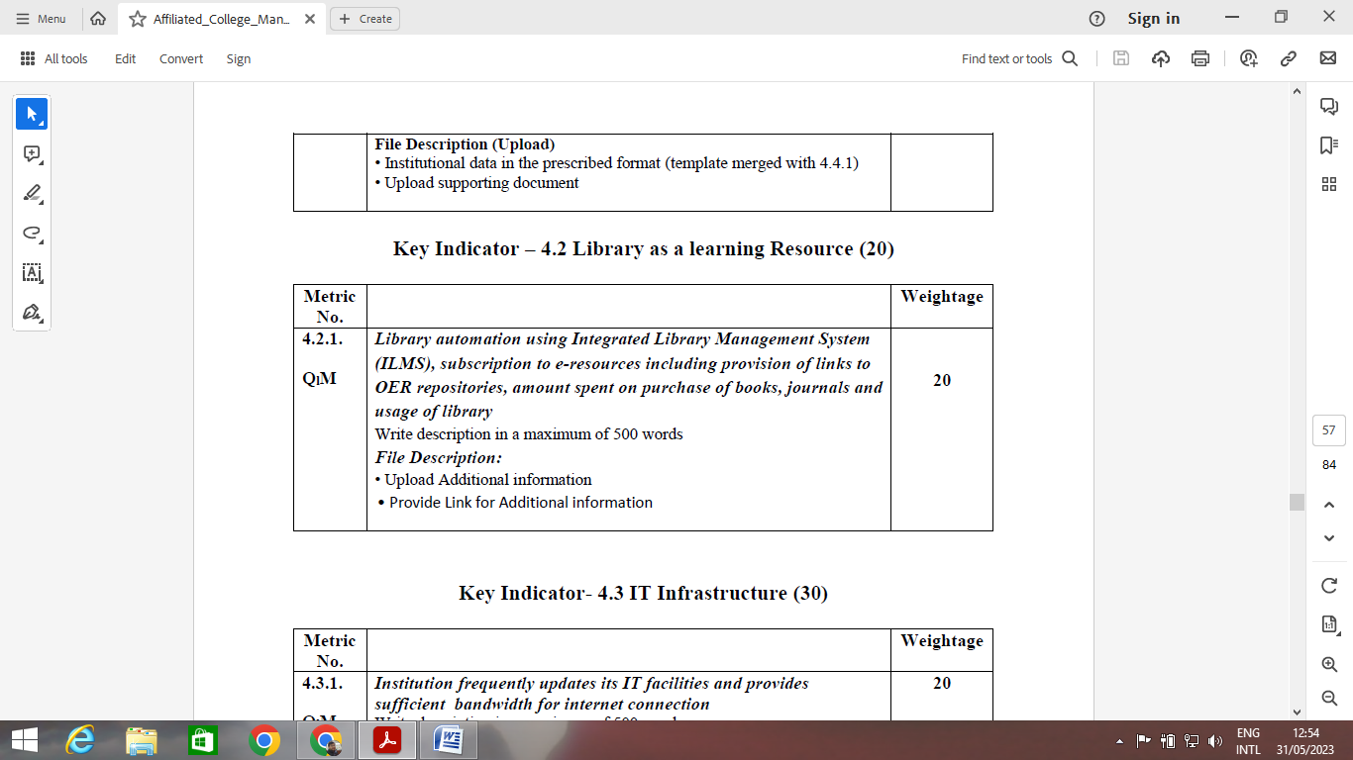

* Fill the Table as per format. (To be discussed with Management)

Year 1

|  |  |  |  |  |
| --- | --- | --- | --- | --- |
| S. NO | Name of the equipment | Make | Department | Cost |
|  |  |  |  |  |

Year 2



* Log register for the last 45 days to be uploaded.
* Subscription bills of e-resources, Printed books / Journals.
* OPAC system description along with library usage and purpose to be included in the text
* Year wise - Amount spent on library (To be highlighted in Balance sheet)

|  |  |  |
| --- | --- | --- |
| S. NO | Year | Amount spent |
| 1 | 2018-19 | xxxxx |
| 2 | 2019-20 | xxxxx |
| 3 | 2020-21 | xxxxx |
| 4 | 2021-22 | xxxxx |
| 5 | 2022-23 | xxxxx |

* Year wise bills to be attached.

|  |  |  |  |  |
| --- | --- | --- | --- | --- |
| S. No | Title of the book | Name of the author | No. of Copies | Total cost |
|  |  |  |  |  |

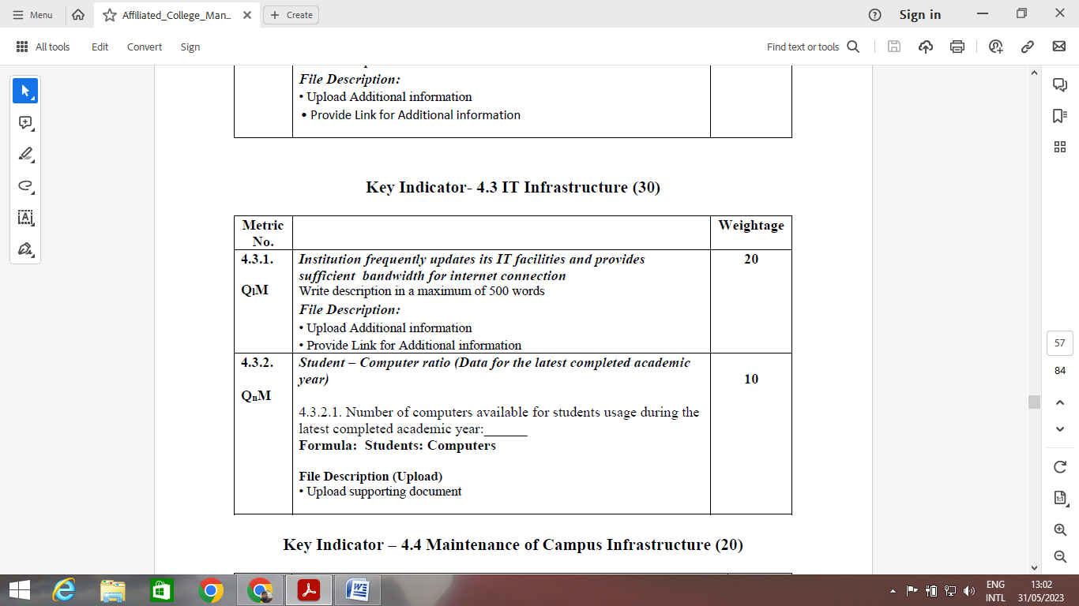

* IT policy to be attached
* List of Software and their bills to be attached
* Wifi bills
* Wifi rating - Screen Print - (while using speed)
* IT maintenance record (Register) complaints and Confirmity.



* Purchase bill of computers in the last 5 years

|  |  |  |  |
| --- | --- | --- | --- |
| Sr. No. | Room No. | No. of Computers | Specifications |

* GPS Photographs to be attached

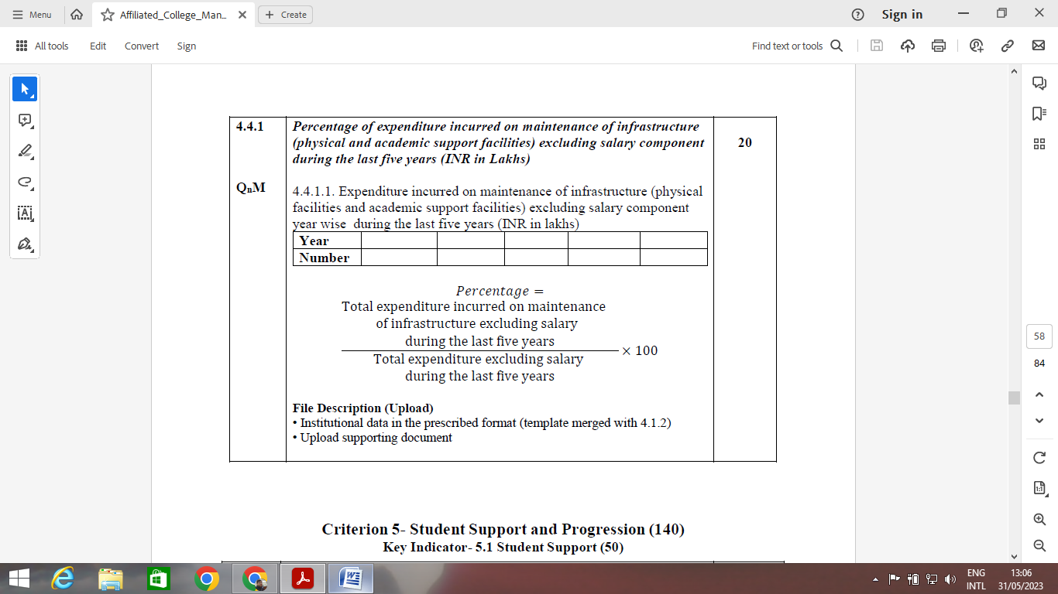

* Balance sheet to be attached - highlight the expenditure incurred.
* Infrastructure maintenance policy to be attached

Year 1

|  |  |  |
| --- | --- | --- |
| S. No | Item | Amount spent |
|  |  |  |

Year 2, Year 3, year 4 and year 5 to be done in the above format